1)Books data set

Business objective: To observe top 10 association rules

Inferences: I have imported the data set and I have first done some cleaning on the data set , I Have first normalized the data set and then I have used the aprioiri algorithm and I have used different support, confidence, min_len,max_len, I have observed the scatter plots and the other plots and accordingly,I have changed the above values. After applying all these on books data set ,I have observed that if we can cluster the geobooks,kidsbooks,youth books,refbooks in one place they have high probability of getting sold as they have high support and lift values.

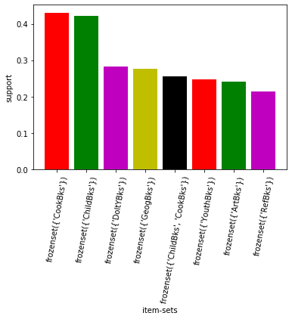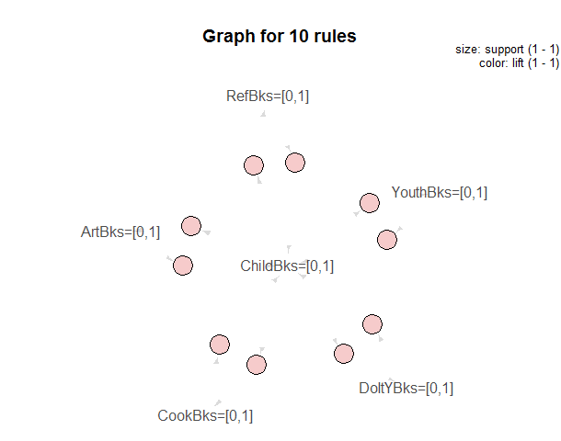

2) groceries dataset

Business objective: To observe top 10 association rules

Inferences:I have imported the data set and I have first done some cleaning on the data set , I Have first normalized the data set and then I have used the aprioiri algorithm and I have used different support, confidence, min_len,max_len, I have observed the scatter plots and the other plots and accordingly,I have changed the above values.

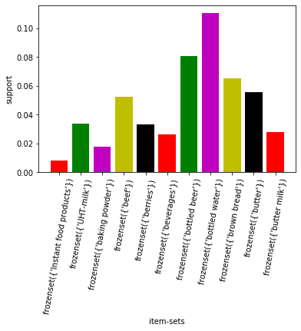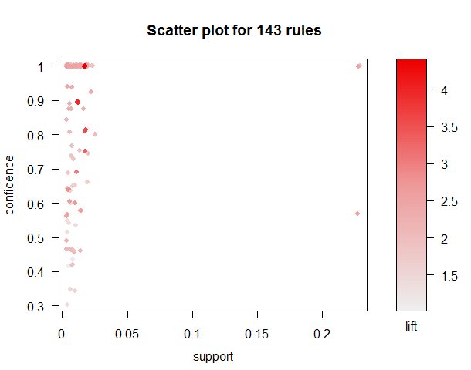

Here, I have formed 143 association rules. In the below 143 grouped matrix plot we can clearly observe some of the columns are having good lift and even some of them are having good support values.So if we can group them at a place ,the customers can easily pick them and we can increase our sales.

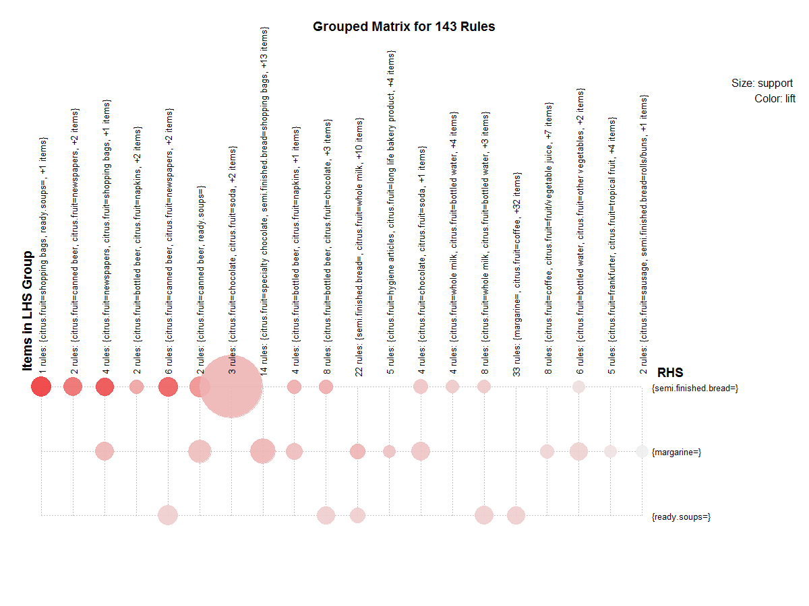

3)phone data set

Business objective: To observe top 10 association rules

Inferences:I have imported the data set and I have first done some cleaning on the data set , I Have first normalized the data set and then I have used the aprioiri algorithm and I have used different support, confidence, min_len,max_len, I have observed the scatter plots and the other plots and accordingly,I have changed the above values

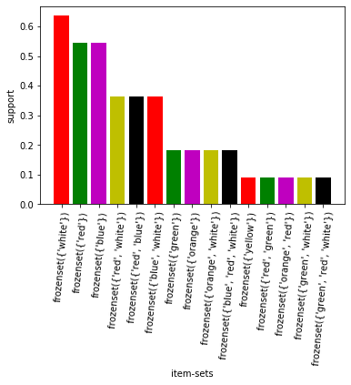 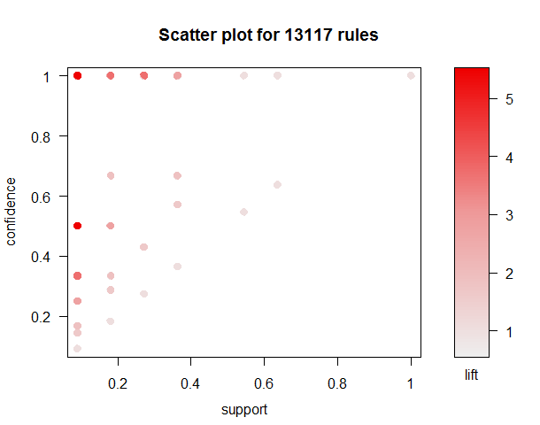

Here, I have formed 13117 association rules. In the below grouped matrix plot we can clearly observe some of the columns are having good lift and even some of them are having good support values.So if we can group them at a place ,the customers can easily pick them and we can increase our sales.

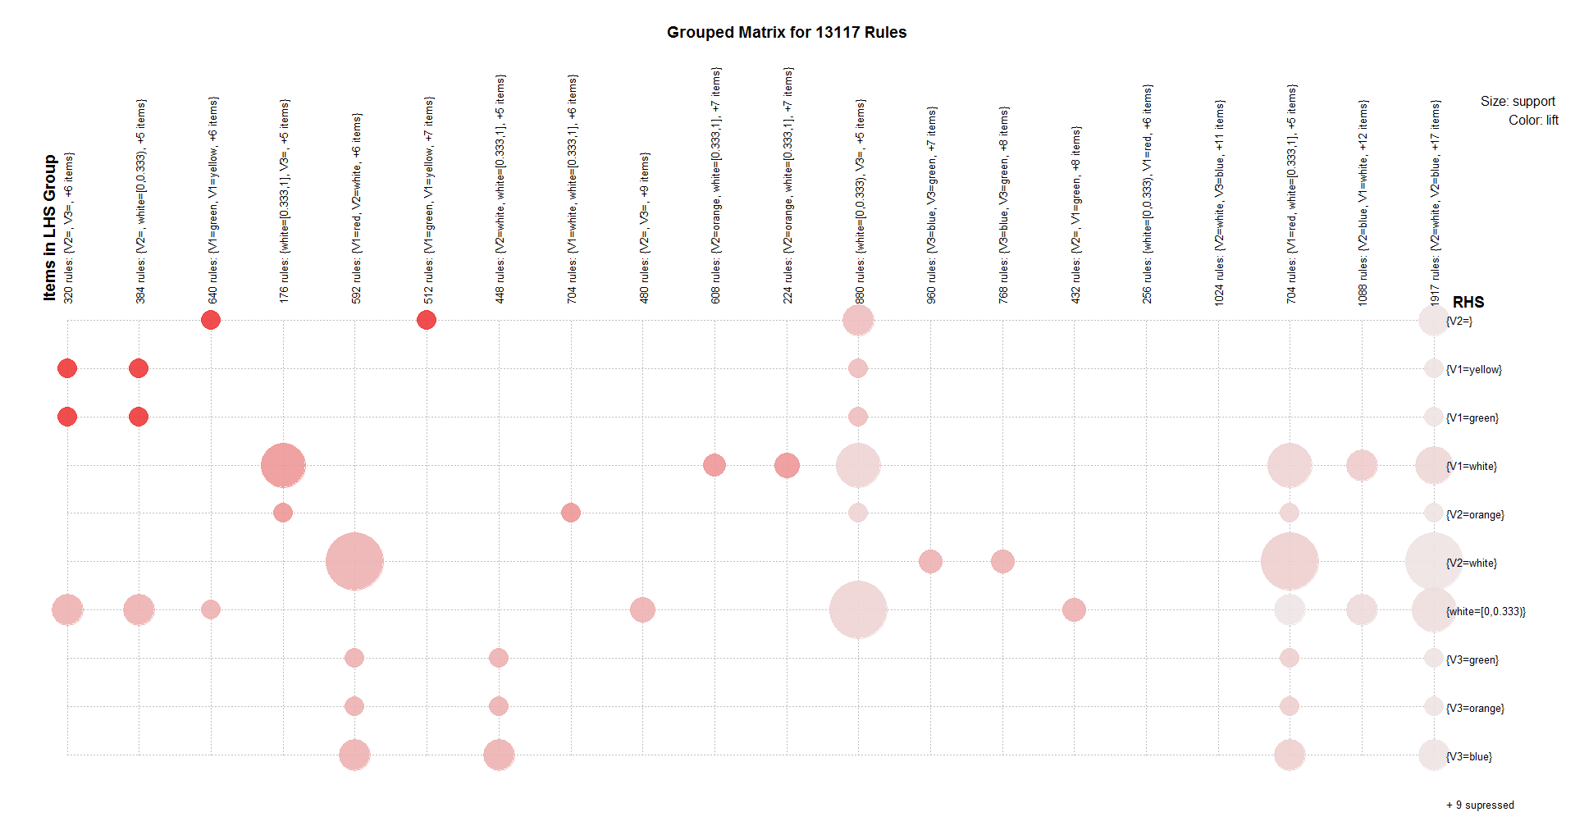

4) movie data set

Business objective: To observe top 10 association rules

Inferences:I have imported the data set and I have first done some cleaning on the data set , I Have first normalized the data set and then I have used the aprioiri algorithm and I have used different support, confidence, min_len,max_len, I have observed the scatter plots and the other plots and accordingly,I have changed the above values

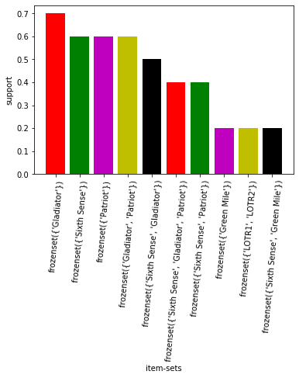

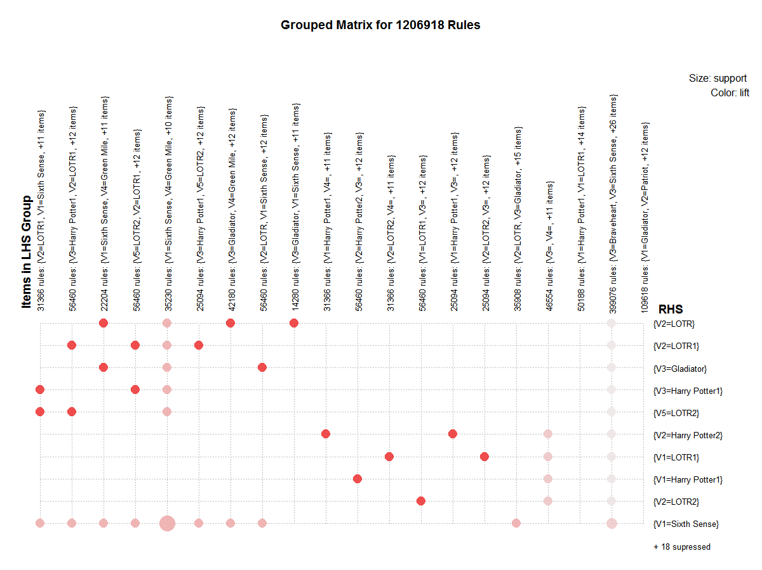

Here, I have formed 1201 association rules. In the below grouped matrix plot we can clearly observe some of the columns are having good lift and even some of them are having good support values.So if we can recommend these movies to our customers they will be a high probability of them watching these films.

5) retail data set

Business objective: To observe top 10 association rules

Inferences:I have imported the data set and I have first done some cleaning on the data set , I Have first normalized the data set and then I have used the aprioiri algorithm and I have used different support, confidence, min_len,max_len, I have observed the scatter plots and the other plots and accordingly,I have changed the above values.This data set contains all the household objects and it is pretty much similar to the groceries data set.

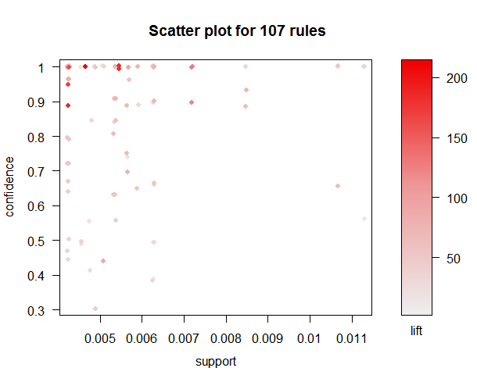

Here, I have formed 107 association rules. In the below grouped matrix plot we can clearly observe some of the columns are having good lift and even some of them are having good support values.So if we can group them at a place ,the customers can easily pick them and we can increase our sales.

